**SECTION A-46 MARKS**

**Attempt** all **questions in this section.**

1. Balance the following nuclear equations and in each case identify M. (@01 mark)
2. ${}_{3}^{7}{Li}$ + ${}_{1}^{1}H$ 2M, M = ……………………
3. ${}_{98}^{250}{Cf}$ + M ${}_{103}^{257}{Lw}$ + 4 ${}_{0}^{1}n$, M = …………………..
4. A radioactive nucleus had an initial activity of **12.4** counts per minutes, which reduced by **75%** after **13.5** minutes. Determine the half-life of the nucleus. (03 marks)

……………………………………………………………………………………………………………………………………………………………………………………………………………………………………………………………………………………………………………………………………………………………………………………………………………………………………………………………………………………………………………………………………………………………………………………………………………………………………………………………………………………………………………………………………………………………………………………………………………………………………………………………………………………………………………………………………………

1. Write equations for the reactions that take place when the following substances are reacted with aqueous sodium hydroxide. (@01½ marks)
2. Aluminium oxide.

……………………………………………………………………………………………………………………………………………………………………

1. Beryllium oxide.

……………………………………………………………………………………………………………………………………………………………………

1. Chromium VI) oxide.

……………………………………………………………………………………………………………………………………………………………………

1. State giving equations, what would be observed when the following pairs of compounds are mixed.
2. Phenol and bromine water. (02 marks)

Observation:

…………………………………………………………………………………

Equation:

………………………………………………………………………………………………………………………………………………………………………………………………………………………………………………………

1. Propyne and ammoniacial silver nitrate solution. (02 marks)

Observation:

…………………………………………………………………………………

Equation:

……………………………………………………………………………………………………………………………………………………………………

1. Methylcyclohexene and alkaline potassium manganate (VII) solution. (02 marks)

Observation:

………………………………………………………………………………………………………………………………………………………………………………………………………………………………………………………

Equation:

………………………………………………………………………………………………………………………………………………………………………………………………………………………………………………………

1. Define the term steam distillation. (01 mark)

…………………………………………………………………………………………………………………………………………………………………………………………………………………………………………………………………………………………………………………………………………

1. Mention two requirements for a component to be separated by steam distillation. (01 mark)

…………………………………………………………………………………………………………………………………………………………………………………………………………………………………………………………………………………………………………………………………………

1. A mixture containing a substance, Q was steam distilled at **760mmHg** at a temperature of **96ᵒC**. The distilled contained **15%** by mass of substance, **Q**. If the vapour pressure of water is **734mmHg** at the same temperature. Calculate the molar mass of substance, **Q**. (03 marks)

……………………………………………………………………………………………………………………………………………………………………………………………………………………………………………………………………………………………………………………………………………………………………………………………………………………………………………………………………………………………………………………………………………………………………………………………………………………………………………………………………………………………………………………………………………………………………………………………………………………………………………………………………………………………………………………………………………

1. State one advantage of using steam distillation in purification. (0½ mark)

…………………………………………………………………………………………………………………………………………………………………………………………………………………………………………………………………………………………………………………………………………

1. State how the following organic substances can be synthesized. [Equations are NOT required]
2.  (02½ marks)

……………………………………………………………………………………………………………………………………………………………………………………………………………………………………………………………………………………………………………………………………………………………………………………………………………………………………………………………………………………………………………………………………………………………………………………………………………………………………………………………………………………………………………………………………………………………………………………………………………………………………………………………………………………

1.  (03 marks)

…………………………………………………………………………………………………………………………………………………………………………………………………………………………………………………………………………………………………………………………………………………………………………………………………………………………………………………………………………………………………………………………………………………………………………………………………………………………………………………………………………………………………………………………………………………………………………………………………………………………………………………………

1. State what is meant by the term first electron affinity. (01 mark)

……………………………………………………………………………………………………………………………………………………………………………………………………………………………………………………………………………………………………………………………………………………………………………………………………………………………

1. The table below shows the first electron affinities of halogens.

|  |  |  |  |  |
| --- | --- | --- | --- | --- |
| Halogens | F | Cl | Br | I |
| First electron affinities [kJ/mol] | -328 | -349 | -325 | -295 |

1. State the trend of electron affinities amongst the halogens down the group. (01 mark)

…………………………………………………………………………………………………………………………………………………………………………………………………………………………………………………………………………………………………………………………………………

1. Explain the observed trend in (i) above. (03 marks)

…………………………………………………………………………………………………………………………………………………………………………………………………………………………………………………………………………………………………………………………………………………………………………………………………………………………………………………………………………………………………………………………………………………………………………………………………………………………………………………………………………………………………………………………………………………………………………………………………………………………………………………………

1. **25.0cm3** of gaseous hydrocarbon, W was exploded with **200.0cm3** of oxygen gas. On cooling to room temperature, the residual gases occupied **150.0cm3**. After shaking with concentrated potassium hydroxide solution, the final volume was **50.0cm3**.
2. Determine the molecular formula gaseous hydrocarbon, W. (02½ marks)

…………………………………………………………………………………………………………………………………………………………………………………………………………………………………………………………………………………………………………………………………………………………………………………………………………………………………………………………………………………………………………………………………………………………………………………………………………………………………………………………………………………………………………………………………………………………………………………………………………………………………………………………

1. Write the structural formulae of all the possible isomers of gaseous hydrocarbon, W and give the IUPAC names. (02 marks)

……………………………………………………………………………………………………………………………………………………………………………………………………………………………………………………………………………………………………………………………………………………………………………………………………………………………………………………………………………………………………………..

1. Define the term bond energy. (01 mark)

…………………………………………………………………………………………………………………………………………………………………………………………………………………………………………………………………………………………………………………………………………

1. State how any one factor affects bond energy. (01 mark)

………………………………………………………………………………………………………………………………………………………………………………………………………………………………………………………

1. The enthalpy of formation of phosphorous (V) chloride is -664.35kJ/mol & the enthalpies of atomization of phosphorous and chlorine gases are +314 & +242kJ/mol respectively. Calculate the average bond energy of phosphorous – chlorine [P-Cl] bonds. (03 marks)

………………………………………………………………………………………………………………………………………………………………………………………………………………………………………………………………………………………………………………………………………………………………………………………………………………………………………………………………………………………………………………………………………………………………………………………………………………………………………………………………………………………………………………………………………………………………………

1. State what is meant by the term depression freezing point constant? (01 mark)

…………………………………………………………………………………………………………………………………………………………………………………………………………………………………………………………………………………………………………………………………………

1. A solution containing x g of compound, Y [RFM = 74] in 20g of benzene had a depression in freezing point of 4.15ᵒC. Determine the value of x. (03½ marks)

………………………………………………………………………………………………………………………………………………………………………………………………………………………………………………………………………………………………………………………………………………………………………………………………………………………………………………………………………………………………………………………………………………………………………………………………………………………………………………………………………………………………………………………………………………………………………

1. How would the value of relative formula mass can be affected if the solute, Y dissociated in benzene? (01½ marks)

………………………………………………………………………………………………………………………………………………………………………………………………………………………………………………………………………………………………………………………………………………………………………………………………………………………………………………………………………………………………………………………………………………………………………………………………………………………………………………………………………………………………………………………………………………………………………

**SECTION B-54 MARKS**

**Attempt** ANY **SIX questions in this section.**

1. Both aminobenzene and N,N-dimethylaminobenzene react with an ice cold mixture of aqueous sodium nitrite and concentrated hydrochloric acid to give colourless solution.
2. Give the structural formula of: (@01 mark)
3. Aminobenzene.

……………………………………………………………………………………………………………………………………………………………………

1. N,N-dimethylaminobenzene.

……………………………………………………………………………………………………………………………………………………………………

1. Name one reagent that can be used to distinguish between the two amino compounds using the colourless solutions formed. (01 mark)

…………………………………………………………………………………

1. State what would be observed if the solutions are separately treated with the named reagent in b (i). (02 marks)

……………………………………………………………………………………………………………………………………………………………………………………………………………………………………………………………………………………………………………………………………………………………………………………………………………………………

1. Write equation(s) to show aminobenzene can be prepared from ethyne. (04 marks)

………………………………………………………………………………………………………………………………………………………………………………………………………………………………………………………………………………………………………………………………………………………………………………………………………………………………………………………………………………………………………………………………………………………………………………………………………………………………………………………………………………………………………………………………………………………………………

1. When red lead, Pb3O4 was reacted with nitric acid a solid was formed. Write equation for the reaction that took place. (01½ marks)

……………………………………………………………………………………………………………………………………………………………………

1. The mixture from (a) was filtered and the residue dissolved in an acidified solution of manganese (II) sulphate. Explain what was observed and write equations for the reaction. (03 marks)

……………………………………………………………………………………………………………………………………………………………………………………………………………………………………………………………………………………………………………………………………………………………………………………………………………………………………………………………………………………………………………..

1. The filtrate from (a) above was divided in to two parts:
2. To the first portion was added aqueous potassium chromate. State what was observed and write the equation for the reaction. (01½ marks)

…………………………………………………………………………………………………………………………………………………………………..

1. The second part was evaporated to dryness and heated very strongly and allowed to cool. State what was observed. (01½ marks)

…………………………………………………………………………………………………………………………………………………………………..

1. Write equation for the reaction that took place when the formed residue was dissolved in hot sodium hydroxide solution. (01½ marks)

……………………………………………………………………………………………………………………………………………………………………………………………………………………………………………………………………………………………………………………………………………………………………………………………………………………………

1. The following half-cell reactions are given below:

I2(aq) + 2e 2I-(aq) Eθ = +0.34V

PbO2(s) +4H+(aq)+2e Pb2+(aq) + 2H2O(l) Eθ = +1.46V

1. (i) Write the cell notation by combining the two half-cells. (02 marks)

………………………………………………………………………………………………………………………………………………………………………………………………………………………………………………………

(ii)State what will be observed at the: (@01 mark)

Anode:

……………………………………………………………………………………………………………………………………………………………………

Cathode:

……………………………………………………………………………………………………………………………………………………………………

1. (i) Calculate the emf for the cell. (01½ marks)

………………………………………………………………………………………………………………………………………………………………………………………………………………………………………………………

(ii) State whether the reaction is feasible or not. Give a reason for your answer. (01½ marks)

……………………………………………………………………………………………………………………………………………………………………

1. State three factors that influence the magnitude of standard electrode potential. (01½ marks)

………………………………………………………………………………………………………………………………………………………………………………………………………………………………………………………

1. State one application of standard electrode potential. (0½ mark)

………………………………………………………………………………………………………………………………………………………………………………………………………………………………………………………

1. Ammonia undergoes the following reaction in water.

NH3(aq) + H2O(l)  NH4+(aq) + OH-(aq)

Write the expression for the ionization constant, Kb for the reaction. (01 mark)

………………………………………………………………………………………………………………………………………………………………………………………………………………………………………………………

1. Water ionizes according to the equation below:

H2(g) + H2O(l)  H3O+(aq) + OH-(aq) Write the expression for the ionization constant, Kw for water. (01 mark)

…………………………………………………………………………………

1. The hydrolysis of ammonium chloride is given by the equation: NH4+(aq) + H2O(l)  NH3(aq) + H3O+(aq) Deduce the hydrolysis constant, Kh for ammonium chloride in term of Kw & Kb. (03 marks)

………………………………………………………………………………………………………………………………………………………………………………………………………………………………………………………………………………………………………………………………………………………………………………………………………………………………………………………………………………………………………………………………………………………………………………………………………………………………………………………………………………………………………………………………………………………………………………………………………………………………………………………………………………………………………………………………………………………………………………………………………………………………

1. Calculate:
2. Hydrolysis constant, Kh for ammonium chloride. (01 mark)

………………………………………………………………………………………………………………………………………………………………………………………………………………………………………………………

1. Hydrogen ion concentration. (01 mark)

……………………………………………………………………………………………………………………………………………………………………………………………………………………………………………………………………………………………………………………………………………………………………………………………………………………………

1. pH of a 0.01M ammonium chloride solution at room temperature. (02 marks)

[Kw = 1.0 x10-14mol2/dm6, Kb = 1.8 x10-5mol/dm3]

………………………………………………………………………………………………………………………………………………………………………………………………………………………………………………………

1. Outline the processes involved in the large scale production of chlorine gas. [Diagram NOT required] (03 marks)

…………………………………………………………………………………………………………………………………………………………………………………………………………………………………………………………………………………………………………………………………………………………………………………………………………………………………………………………………………………………………………………………………………………………………………………………………………………………………………………………………………………..

1. Write equations to show how chlorine gas reacts with:
2. Hot concentrated sodium hydroxide solution. (01½ marks)

……………………………………………………………………………………………………………………………………………………………………

1. Sulphur dioxide. (01½ marks)

……………………………………………………………………………………………………………………………………………………………………

1. When reacted together, a mixture of sodium chloride and concentrated sulphuric acid liberates hydrogen chloride gas however a similar mixture of sodium iodide and sulphuric acid liberates iodine instead. Explain this observation. (03 marks)

………………………………………………………………………………………………………………………………………………………………………………………………………………………………………………………………………………………………………………………………………………………………………………………………………………………………………………………………………………………………………………………………………………………………………………………………………………………………………………………………………………………………………………………………………………………………………

1. An organic compound, H contains 80% carbon, 6.7% hydrogen and the rest being oxygen. Determine the empirical formula of organic compound, H. (02½ marks)

………………………………………………………………………………………………………………………………………………………………………………………………………………………………………………………………………………………………………………………………………………………………………………………………………………………………………………………………………………………………………………………………………………………………………………………………………………………………………………………………………………………………………………………………………………………………………………………………………………………………………………………..

1. 0.5g of hydrocarbon, H when vaporized at a temperature of 150ᵒC and pressure of 760mmHg occupied a volume of 144.6cm3.
2. Determine the molecular mass of hydrocarbon, H and hence its molecular formula. (03½ marks)

………………………………………………………………………………………………………………………………………………………………………………………………………………………………………………………………………………………………………………………………………………………………………………………………………………………………………………………………………………………………………………………………………………………………………………………………………………………………………………………………………………………………………………………………………………………………………………………………………………………………………………………..

1. Write the structures of the possible isomers of hydrocarbon, H. (01 mark)

………………………………………………………………………………………………………………………………………………………………………………………………………………………………………………………

1. Hydrocarbon, H burns with a yellow sooty flame, forms a yellow orange precipitate with Brady’s reagent and also reacts with iodine in sodium hydroxide solution to form a yellow solid. Write the structure of hydrocarbon, H. (01 mark)

………………………………………………………………………………………………………………………………………………………………………………………………………………………………………………………

1. Write equation for the reaction between hydrocarbon, H and Brady’s reagent. (01 mark)

…………………………………………………………………………………………………………………………………………………………………………………………………………………………………………………………………………………………………………………………………………

1. Name the ore used in the extraction of aluminium. (0½ mark)

…………………………………………………………………………………

1. Write the formula of the ore named in a (i) above. (0½ mark)

…………………………………………………………………………………

1. During the extraction process of aluminium, the ore is treated with hot concentrated sodium hydroxide solution.
2. Briefly state what happens to the ore when treated with sodium hydroxide solution. (02 marks)

………………………………………………………………………………………………………………………………………………………………………………………………………………………………………………………………………………………………………………………………………………………………………………………………………………………………………………………………………………………………………………

1. Write equations for the reactions that take place in b (i) above. (02½ marks)

………………………………………………………………………………………………………………………………………………………………………………………………………………………………………………………………………………………………………………………………………………………………………………………………………………………………………………………………………………………………………………

1. The soluble complex salt of aluminum obtained in (b) is taken by through several reactions to form pure aluminium oxide.
2. State how the purified aluminium oxide is treated to form pure aluminium. (01½ marks)

………………………………………………………………………………………………………………………………………………………………………………………………………………………………………………………………………………………………………………………………………………………………………………………………………………………………………………………………………………………………………………

1. Write equation for the reaction that takes place. (01 mark)

……………………………………………………………………………………………………………………………………………………………………

1. Explain any one use of aluminium. (01 mark)

……………………………………………………………………………………………………………………………………………………………………………………………………………………………………………………………………………………………………………………………………………………………………………………………………………………………

1. Complete the following reactions and in each case write a mechanism.
2. CH3CH2COCl ………………………. (03 marks)

………………………………………………………………………………………………………………………………………………………………………………………………………………………………………………………………………………………………………………………………………………………………………………………………………………………………………………………………………………………………

1. CH3CH(CH3)COCH3 ………………………….(03 marks)

………………………………………………………………………………………………………………………………………………………………………………………………………………………………………………………………………………………………………………………………………………………………………………………………………………………………………………………………………………………………

1.  …………………………. (03 marks)

………………………………………………………………………………………………………………………………………………………………………………………………………………………………………………………………………………………………………………………………………………………………………………………………………………………………………………………………………………………………

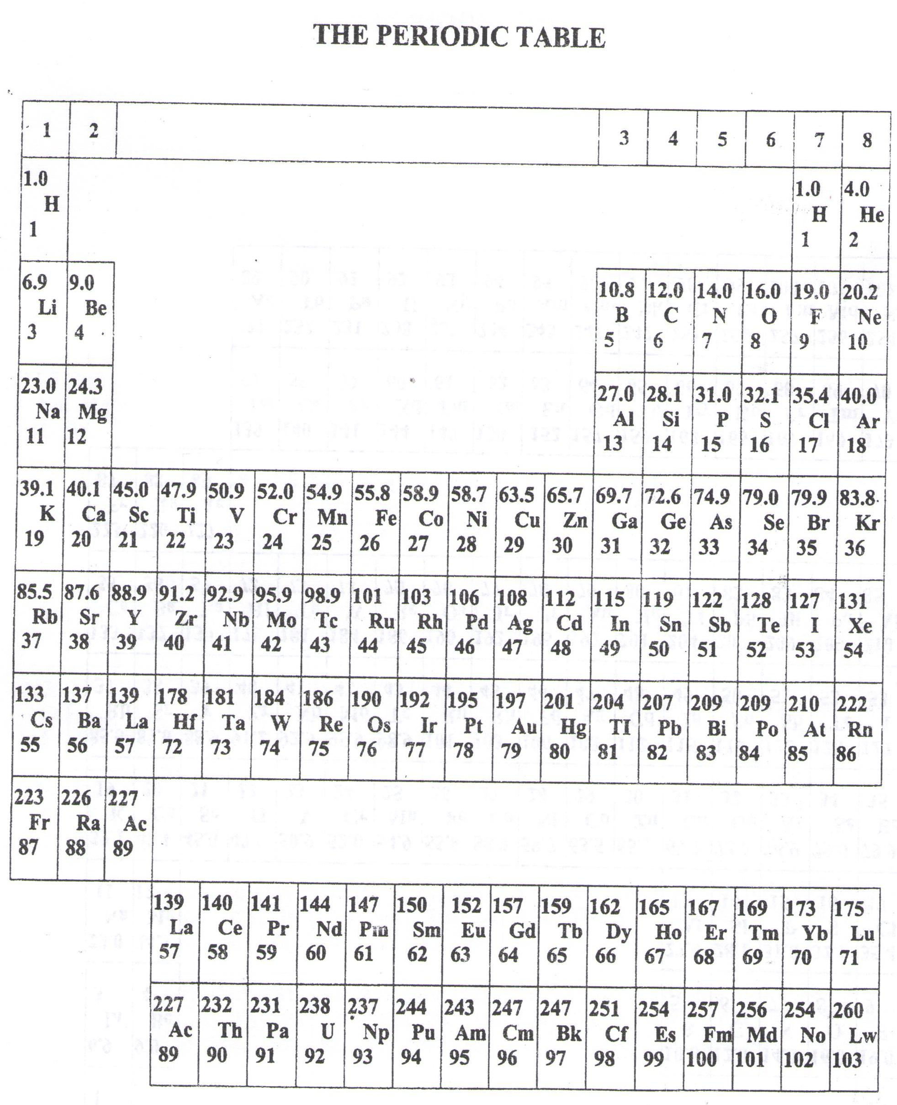

* ===END===

WELCOME TO SENIOR SIX, YEAR 2023

This is the last page of the printed paper, Page 21